1.Check file can execute

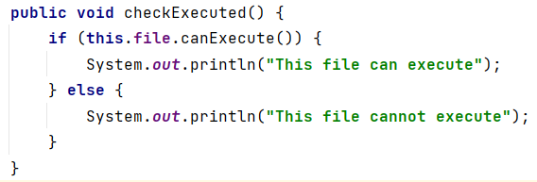

2.Check file can read

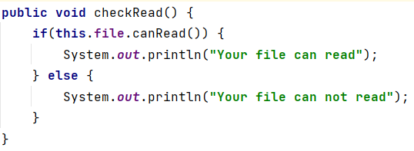

3.Check file can write

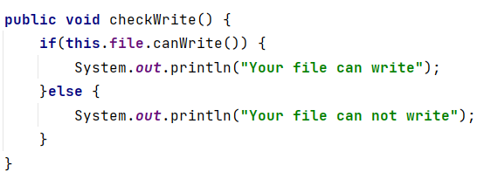

4.print Path of file

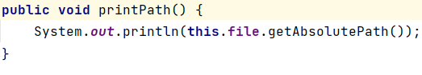

5.Print only file name

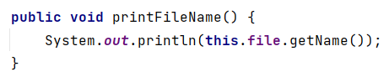

6. Check file is folder or file

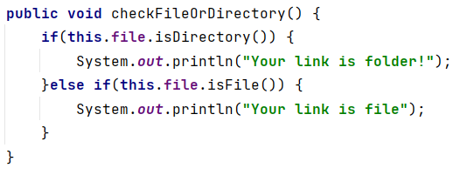

7. Print sub file

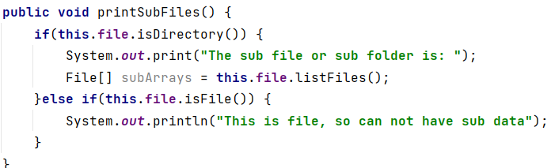

8. Print Full diagram of file(arranged)

